stock market analysis

An analysis of Netflix stocks…Netflix is listed on the NASDAQ exchange under the ticker NFLX, and is part of the Consumer Services category. It's also a FAANG stock, which stands for Facebook, Amazon, Apple, Netflix, and Google.

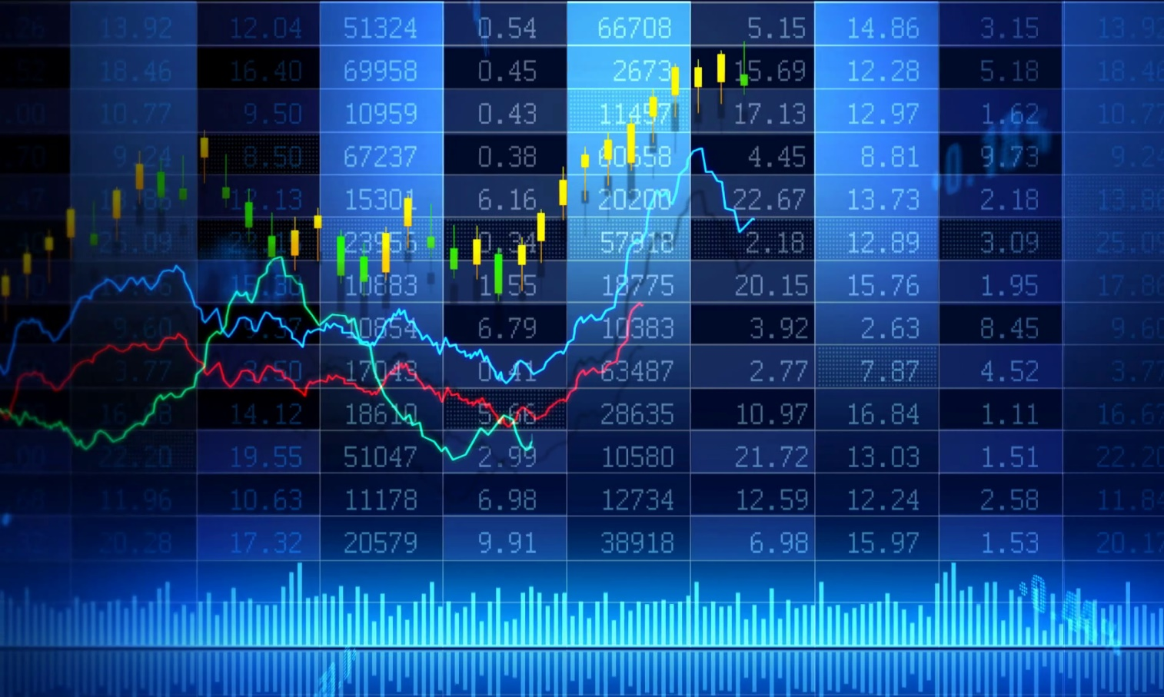

NAME: YANDAPALLI VARSHINI

DR LANKAPALLI BULLAYA COLLAGE

BBA

**TABLE OF CONTENTS**

1. **Introduction**
   1. Overview of the company.
   2. Overview of the company’s stock.
2. **Stock Performance Analysis**
   1. Key Performance Indicators
3. **Comparison with Relative Stock index**
4. **Analysis of External Factors Influencing Stocks**
5. **Conclusion**

# INTRODUCTION

**OVERVIEW OF THE COMPANY(NETFLIX}**

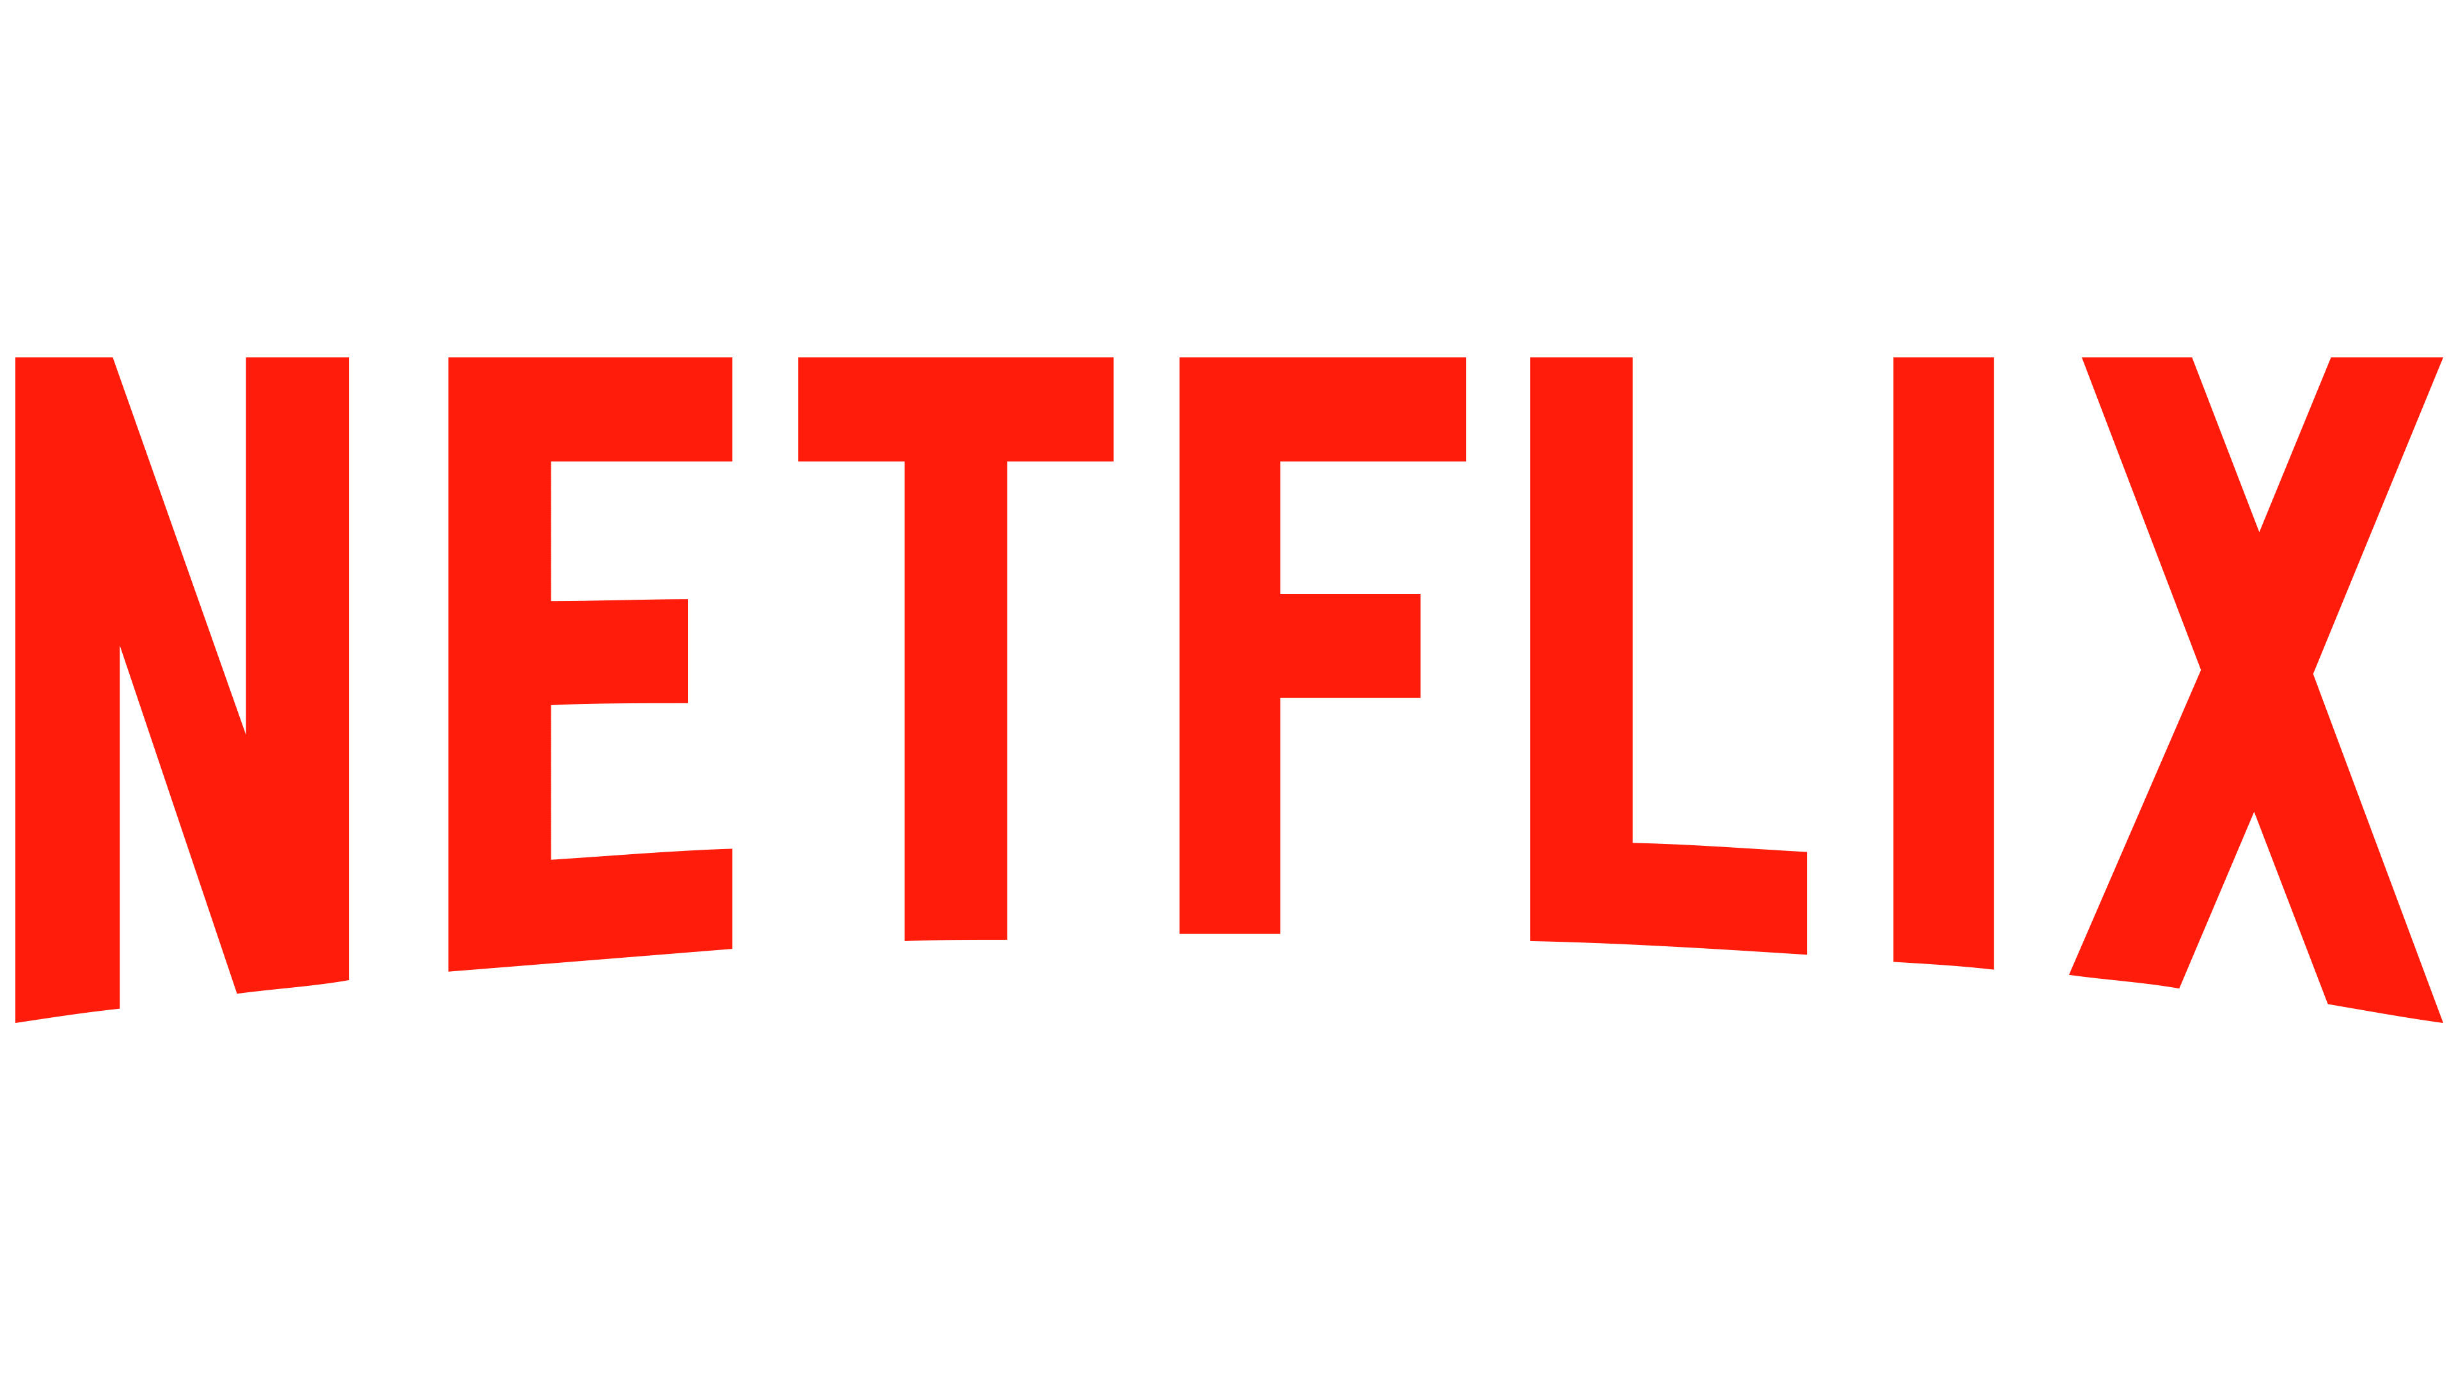 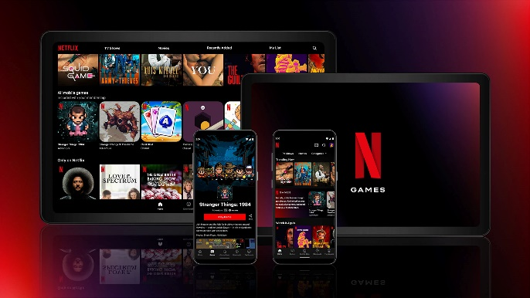

Netflix is an American subscription video-on-demand over-the-top streaming service. The service primarily distributes original and acquired films and television shows from various genres, and it is available internationally in multiple languages.

Launched on January 16, 2007, nearly a decade after Netflix, Inc. began its pioneering DVD‑by‑mail movie rental service, Netflix is the most-subscribed video-on-demand streaming media service, with 260.28 million paid memberships in more than 190 countries as of January 2024. By 2022, "Netflix Original" productions accounted for half of its library in the United States and the namesake company had ventured into other categories, such as video game publishing of mobile games via its flagship service. As of October 2023, Netflix is the 24th most-visited website in the world with 23.66% of its traffic coming from the United States, followed by the United Kingdom at 5.84% and Brazil at 5.64%

Netflix was founded by Marc Randolph and Reed Hastings on August 29, 1997, in Scotts Valley, California. Hastings, a computer scientist and mathematician, was a co-founder of Pure Software, which was acquired by Rational Software that year for $750 million, the then biggest acquisition in Silicon Valley history.

OVERVIEW OF THE COMPANY STOCKS: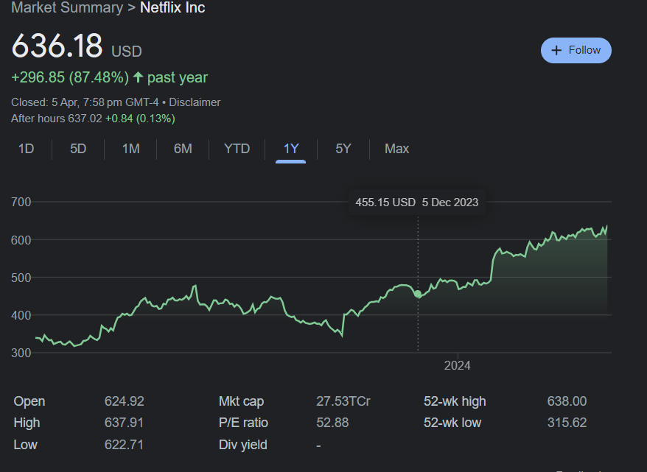

|  |  |
| --- | --- |
| Previous Close | **617.14** |
| Open | **625.30** |
| Bid | **593.22 x 100** |
| Ask | **637.11 x 100** |
| Day's Range | **622.71 - 637.91** |
| 52 Week Range | **315.62 - 638.00** |
| Volume | **3,321,283** |
| Avg. Volume | **4,458,924** |
| Market Cap | **275.313B** |
| Beta (5Y Monthly) | **1.22** |
| PE Ratio (TTM) | **52.93** |
| EPS (TTM) | **12.02** |
| Earnings Date | **Apr 18, 2024** |
| Forward Dividend & Yield | **N/A (N/A)** |
| Ex-Dividend Date | **N/A** |
| 1y Target Est | **612.5** |

STOCK PERFORMANCE ANALYSIS

This section includes the KPIs used to analyze the performance of **NETFLIX. FAANG or class A Common Stock.** Which are as follows:

**PERCENTAGE CHANGE IN STOCK PRICE:**

Currency in USD[Download](https://query1.finance.yahoo.com/v7/finance/download/NFLX?period1=1680764522&period2=1712386922&interval=1mo&events=history&includeAdjustedClose=true)

| Date | Open | High | Low | Close* | Adj Close** | Volume |
| --- | --- | --- | --- | --- | --- | --- |
| Apr 05, 2024 | 625.30 | 637.91 | 622.71 | 636.18 | 636.18 | 3,321,283 |
| Apr 01, 2024 | 608.00 | 638.00 | 605.51 | 636.18 | 636.18 | 13,513,400 |
| Mar 01, 2024 | 599.81 | 634.39 | 592.00 | 607.33 | 607.33 | 60,140,100 |
| Feb 01, 2024 | 567.02 | 605.36 | 549.00 | 602.92 | 602.92 | 71,652,900 |
| Jan 01, 2024 | 483.19 | 579.64 | 461.86 | 564.11 | 564.11 | 145,889,000 |
| Dec 01, 2023 | 473.17 | 500.89 | 445.73 | 486.88 | 486.88 | 80,411,900 |
| Nov 01, 2023 | 414.77 | 482.70 | 414.18 | 473.97 | 473.97 | 71,741,400 |
| Oct 01, 2023 | 377.48 | 418.84 | 344.73 | 411.69 | 411.69 | 164,021,900 |
| Sep 01, 2023 | 437.73 | 453.45 | 371.10 | 377.60 | 377.60 | 100,278,600 |
| Aug 01, 2023 | 437.37 | 445.25 | 398.15 | 433.68 | 433.68 | 107,298,900 |
| Jul 01, 2023 | 439.76 | 485.00 | 411.88 | 438.97 | 438.97 | 168,720,200 |
| Jun 01, 2023 | 397.41 | 448.65 | 393.08 | 440.49 | 440.49 | 147,230,800 |
| May 01, 2023 | 329.44 | 405.11 | 315.62 | 395.23 | 395.23 | 145,471,700 |
| *Close price adjusted for splits.**Adjusted close price adjusted for splits and dividend and/or capital gain distributions. | | | | | | |

**STOCK PRICE VOLATILITY:**

he current Netflix, Inc. volatility is **6.68%**, representing the average percentage change in the investments's value, either up or down over the past month. The chart below shows the rolling one-month volatility.

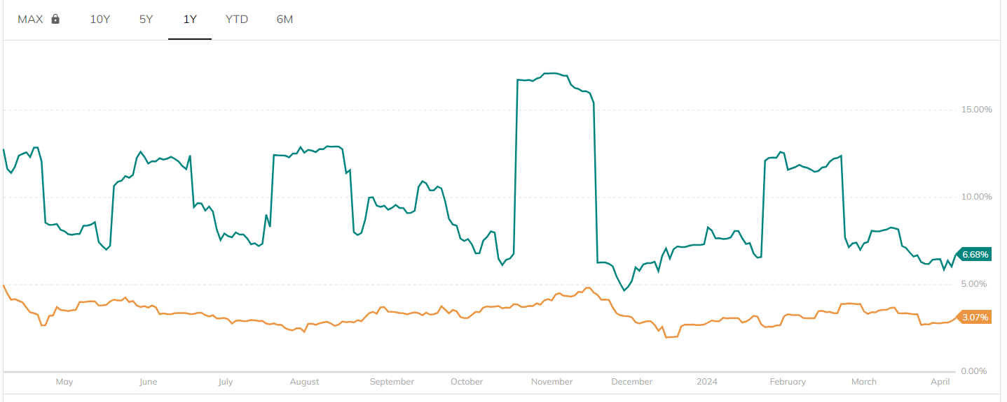

**AVERAGE TRADING VOLUME:**

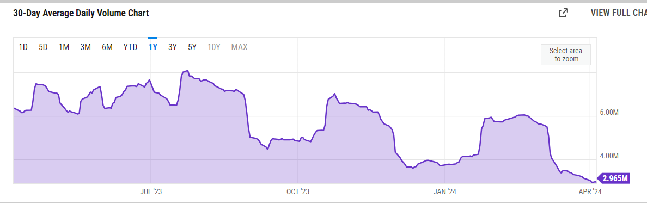

**COMPARISON WITH RELATIVE STOCK INDEX**

**Netflix Inc (NFLX)**

**636.18 +19.04 (+3.09%) 04/05/24 [NASDAQ]**

**636.90 x 2 638.00 x 1 POST-MARKET 637.02 +0.84 (+0.13%) 19:58 ET**

**INTERACTIVE CHART for Fri, Apr 5th, 2024**

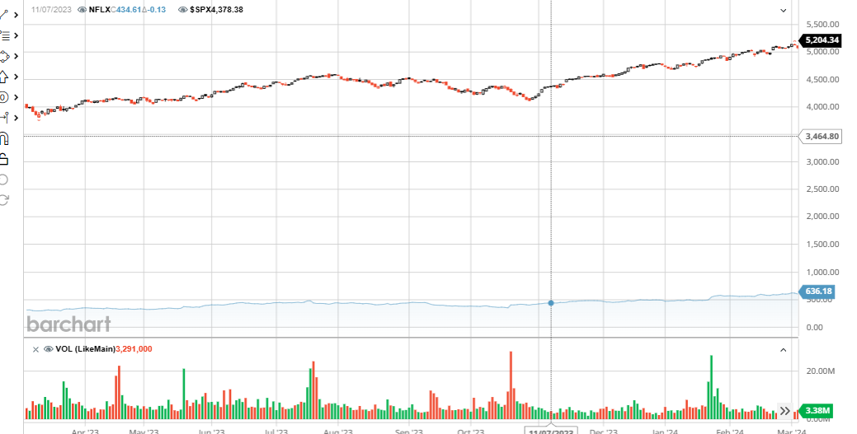

**BLACK represents S&P 500**

**Red represents Netflix**

|  |  |  |
| --- | --- | --- |
| Symbol | NFLX | $SPX |
| Company | Netflix Inc | S&P 500 Index |
| **Price Information** |
| Exchange | NASDAQ | INDEX/CBOE |
| Open | 624.92 | 5,158.95 |
| High | 637.91 | 5,222.18 |
| Low | 622.71 | 5,157.36 |
| Last | 636.18 | 5,204.34 |
| Change | +19.04 | +57.13 |
| % Change | +3.09% | +1.11% |
| Volume | 3,378,800 | 0 |
| 20-Day Average Volume | 2,865,860 | 0 |
| Previous Close | 617.14 | 5,147.21 |
| Industry | Broadcast - Radio & TV | N/A |
| Has Options | Yes | Yes |
| **Technicals** |
| 20-Day Moving Average | 617.61 | 5,190.76 |
| 20-Day Raw Stochastic | 95.64% | 65.17% |
| 20-Day Relative Strength | 62.37% | 58.12% |
| Weighted Alpha | +93.25 | +27.74 |
| Today's Opinion | 100% Buy | 96% Buy |
| Previous Opinion | 100% Buy | 80% Buy |
| Last Month's Opinion | 100% Buy | 100% Buy |
| **Performance** |
| **5-Days** |
| %Chg | +4.75% since 03/28/24 | -0.95% since 03/28/24 |
| Low | 605.51 on 04/02/24 | 5,146.06 on 04/04/24 |
| High | 638.00 on 04/04/24 | 5,263.95 on 04/01/24 |
| **1-Month** |
| %Chg | +6.30% since 03/05/24 | +2.47% since 03/05/24 |
| Low | 593.56 on 03/06/24 | 5,091.14 on 03/11/24 |
| High | 638.00 on 04/04/24 | 5,264.85 on 03/28/24 |
| **3-Month** |
| %Chg | +34.20% since 01/05/24 | +10.80% since 01/05/24 |
| Low | 472.95 on 01/10/24 | 4,699.99 on 01/08/24 |
| High | 638.00 on 04/04/24 | 5,264.85 on 03/28/24 |
| **6-Month** |
| %Chg | +70.75% since 10/05/23 | +22.22% since 10/05/23 |
| Low | 344.73 on 10/18/23 | 4,103.78 on 10/27/23 |
| High | 638.00 on 04/04/24 | 5,264.85 on 03/28/24 |
| **Key Statistics** |
| Market Capitalization, $K | 275,313,248 | N/A |
| Shares Outstanding, K | 432,760 | N/A |
| Annual Sales | 33,723,300,000 | 0 |
| Annual Net Income | 5,407,990,000 | 0 |
| Last Quarter Sales | 8,832,830,000 | N/A |
| Last Quarter Net Income | 937,840,000 | N/A |
| 60-Month Beta | 1.22 | N/A |
| **Per-Share Information** |
| Most Recent Earnings | 2.11 on 01/23/24 | N/A |
| Latest Earnings Date | 04/18/24 | N/A |
| Most Recent Dividend | N/A | N/A |
| Next Ex-Dividends Date | N/A | N/A |
| **Ratios** |
| Price/Earnings ttm | 51.39 | N/A |

**ANALYSIS OF EXTERNAL FACTORS INFLUENCING THE NETFLIX STOCKS**

Many external factors can influence Netflix's stock price, including political, economic, social, and market factors. Here are some of these factors:

* Political factors

Government stability, trade union activities, bureaucracy, and government tariffs can impact Netflix's financial performance.

* Legislative and taxation changes

Netflix's international expansion has put a lot of emphasis on content localization, which means it will have to deal with government censorship in various jurisdictions and weak piracy laws in many locations.

* Competition

The streaming industry is characterized by intense competition, with numerous players vying for consumer attention. Netflix faces challenges from traditional media companies, new entrants, and alternative entertainment options such as social media and gaming.

* Legal factors

These factors are related to the legal policies or rules and regulations laid down by governments which must be followed by the companies operating in their range. These rules are related to consumer laws, copyright or infringement laws, labor laws, and others.

* Environmental factors

Streaming platforms rely on vast data centers, which are energy-intensive. As environmental concerns gain global prominence, companies are under scrutiny for their sustainability practices.

* Protectionist policies

Some countries have protectionist policies that limit the external influence of online service companies, like Netflix. This legal factor can reduce content availability and make the streaming service less attractive to some audiences.

**KEY EVENTS OF NETFLIX**

Netflix was founded in 1997 by Reed Hastings and Marc Randolph in a small California city called Scotts Valley in Santa Cruz county.

Hastings has said the idea was sparked by a $40 fine he got for renting the movie Apollo 13 from long-dead Blockbuster and returning it six weeks late. While working out at the gym one day, the sting of the fine inspired him to think of a service that allowed one to order a movie online and get it by mail.

According to Marc Randolph, this story is false and was just a marketing gag. Instead, in early 1997, Reed was the CEO of the company they worked for (Pure Atria), and Marc was its VP of Corporate Marketing. Because a looming merger with another firm would leave them both out of a job, Marc says Reed had told him, "Let's come up with an idea and you can run it and I'll fund it."

As they carpooled to work every day from their homes in Santa Cruz to Silicon Valley, Marc, who wanted to start something like Amazon, pitched all sorts of e-commerce ideas to Reed: surfboards, custom-built baseball bats, personalized dog food, and home-delivery shampoo. To all of them, Reed's reply was simply, "that will never work."

Then, Marc heard of a hot new product invented in Japan called the DVD. He realized DVDs would soon replace VHS Cassettes, and after a bit of brainstorming in the car on Highway 17, Reed was sold on the idea.

**CONCLUSION**

Concluding a stock market analysis for Netflix involves summarizing the findings and providing insights into the company's performance and potential future trajectory. Here's a sample conclusion

In conclusion, the analysis of Netflix's stock performance reveals a compelling picture of a company that continues to dominate the streaming entertainment industry. Throughout the examined period, Netflix has demonstrated consistent growth in subscribers, revenue, and market share, fueled by its strong content library and innovative approach to content delivery.

Key strengths identified include Netflix's ability to attract and retain subscribers through its diverse and engaging content offerings, its global expansion strategy, and its investments in original programming. Additionally, the company's technological advancements, such as personalization algorithms and user-friendly interfaces, contribute to enhancing the subscriber experience and fostering customer loyalty.

Despite facing increasing competition from other streaming platforms and traditional media companies entering the digital space, Netflix has maintained its position as a market leader. The company's strong brand recognition, extensive content library, and data-driven decision-making provide a solid foundation for future growth and resilience against competitive pressures.

However, it's essential to acknowledge potential risks and challenges, including rising content production costs, fluctuating subscriber growth rates, and evolving consumer preferences. Additionally, regulatory scrutiny, particularly regarding content censorship and taxation in various regions, could pose challenges to Netflix's expansion efforts.

Looking ahead, Netflix's success will likely hinge on its ability to continue investing in high-quality content, expanding its international footprint, and effectively leveraging data analytics to drive user engagement and retention. Furthermore, strategic partnerships and acquisitions may play a crucial role in sustaining its competitive edge and diversifying its revenue streams.

In conclusion, while uncertainties persist in the ever-evolving streaming landscape, Netflix's strong performance and strategic initiatives position it as a formidable player in the entertainment industry, with considerable potential for long-term growth and value creation for investors. However, prudent monitoring of market dynamics and adaptation to changing consumer preferences will be essential for navigating future challenges and capitalizing on emerging opportunities.

This conclusion encapsulates the key findings of the analysis while providing insights into Netflix's strengths, weaknesses, opportunities, and threats, as well as considerations for investors moving forward.